PCP Approach Guidance

Goal: Workflow to create a prioritized list of tools and strategies for your municipality to gain a better understanding of existing capacity, and need for capacity-building, with respect to program development over subsequent Permit terms.

After selecting your PCP Area, determining your Baseline, changes since 2005 due to development, and then quantifying credits from existing structural and non-structural BMPs, you next need to develop a plan moving forward to achieve your PCP goal of reaching your Allowable Phosphorus Load. This Approach Guidance Tool aims to walk you through major factors influencing decisions that shape your PCP since no two PCPs are likely to be the same.

To start, we first walk you through an inventory of current resources and practices that may be able to play a role in your stormwater management program going forward, if they are not already. This exercise will help you frame opportunities for overlap between achieving Permit compliance and other community goals, such as increasing tree canopy or open space, protecting natural spaces, and adapting to climate change. These co-benefits may eventually factor into BMP prioritizations down the line. CRWA conducted a series of web trainings in the Spring of 2022 on multiple topics related to complying with the PCP. Where relevant to the topic, the specific trainings are referenced in blue. The trainings are available on CRWA’s YouTube page (search Charles River Watershed Association on YouTube)

Assessing the tools currently available to your community and where there are resource gaps is critical to developing a path to achieving Permit compliance. Tools can be anything from the staff you have available, to available land to install BMPs, to political will for policy changes that may drive P-reductions. The tools described below are some, but not all, of the tools to consider during your initial assessment. They can be categorized in a variety of ways, but for our planning exercise, we have organized them into four buckets: Organizational Tools, Natural/Infrastructure Assets or Constraints, Policy/Social Tools, and Economic Development Context.

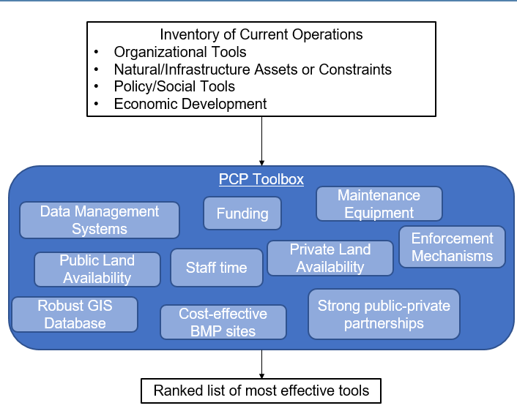
Figure 1. Schematic of Workflow Goals

Perform Inventory
Inventory the current tools at your disposal. Under each category, provide quantifiable responses where possible (e.g. number of staff in departments that may undertake the PCP, amount of funding available, etc.). Add any other tools in each category that may be used to develop or implement your PCP.

Example Assessment Criteria – Use this to guide how you build your inventory.
- What is your estimated future stormwater program budget over the next 3-5 years?
- Available equipment, and do you have the capacity to purchase more equipment?
- What existing stormwater-related contracts do you have (non-structural practices, maintenance, planning, design, etc.)?
- Current FTEs available for your municipal stormwater program (i.e. for maintenance, enforcement, inspections, site visits, plan review, education/outreach, etc.)? Across multiple departments including:
  - DPW/Engineering
  - Conservation
  - Parks/Open Space
  - Planning Department
  - Other
- Any existing plans/designs that could be leveraged (open space plans, past subwatershed plans, concept designs, community-supported designs, climate action plans, etc.)?
- Have you performed assessments of additional funding sources (Stormwater utility feasibility study, grants, CPA, etc.)?
- Review your legal analysis, what tools are in place or planned to require or incentivize BMPs on private property? See PCP Workshop #2 for examples.
- Review your legal analysis, what data reporting and record-keeping requirements are in place or planned to require or incentivize BMPs on private property? See PCP Workshop #2 for examples.
- Available space (street, public parcels, parking lots, parks, schools, etc.)
- Opportunities for savings (Water Management Act permit compliance, I/I reduction, flood mitigation)
- Technical expertise
  - In House
  - On boards/commissions that provide project review
  - Available for free (MAPC technical assistance, local watershed associations, regional stormwater groups)
- Technical tools (Accurate and up-to-date GIS data, stormwater system model, Flood Models, BATT, OptiTool, asset management system, BMP installation, and tracking spreadsheets)
- Existing /potential public-private partnerships or public-public partnerships (DCR, DCAMM, MassDOT, Army Corps, etc.)
- Town master plan/data on rate of development/redevelopment, upcoming development/redevelopment projects
- Strength of enforcement mechanisms, and capacity to conduct enforcement inspections

Organizational Tools
- Staff Resources
Table 1. Staff Resources Assessment
Staff Resources
Number of staff
Training / Expertise
Experience
Skills/staff needed
Additional working hours needed
Add rows as needed

Notes: _________________________________________________________________
_____________________________________________________________________
___________________________________________________________________________________________________________________________________________
_____________________________________________________________________
- Funding Source
Table 2. Funding Source Assessment
Existing Funding |  |  | Anticipated Funding
Type of Funding | Amount ($) | Purpose | Amount ($) | Purpose
e.g. enterprise/utility, general fund, etc.
Add rows as needed

Notes:
______________________________________________________________________
______________________________________________________________________
____________________________________________________________________________________________________________________________________________

- IT Infrastructure
Table 3. IT Infrastructure Inventory
IT Infrastructure Type | Availability/Version
Asset Management System
GIS
Database Management
BATT
MS Office
Adobe
Add rows as needed

- Other_________________________________________________________________
______________________________________________________________________
____________________________________________________________________________________________________________________________________________
______________________________________________________________________

Natural/Infrastructure Assets or Constraints
- Equipment Inventory
Table 4. Equipment Inventory
Existing Equipment | Type | Quantity | Age | Maintenance
 | e.g. street sweeper/type, Vac Trucks, GI maintenance, etc.
Equipment needed

- Open Space
Table 5. Open Space Assessment
Open Space | Management Type | Area (acre) | Land Use | Soil Type | Forested/not forested | Conservation/ protection status
 | publicly held
 | privately held
Add more rows as needed

- Wetland Resources
Table 6. Wetland Resources Assessment
Wetland Resources (name, location reference) | Condition / Impairments
Add more rows as needed

- Planned capital projects
Table 7. Planned Projects Description
Project type | Components | Cost ($) | Land use conversion (y/n)* | Project Area | GSI Opportunity (y/n)
Add more rows as needed
*Workshops #1 and 2 provide important details on the impacts of changing land use on your phosphorus reduction requirements

- Municipally owned land (not already noted above)
Table 8. Municipally Owned Land
Property | Area (acre) | Land Use | Soil Type | Forested/not forested | Conservation/ protection status
Add more rows as needed

- Climate adaptation/resilience actions identified through the MVP process that will have stormwater control benefits
Table 9. Climate Actions
Climate adaptation/resilience actions | Identification process | Stormwater control benefits
Ex. Local wetland bylaw | MVP | Less impervious cover, more projects under con comm review

- Other: ________________________________________________________________
_____________________________________________________________________
__________________________________________________________________________________________________________________________________________

Policy/Social Tools

- Regulatory Controls
Table 10. Regulatory Tools
Regulatory Controls | Yes or No? | Key Features (properties captured, level of control)
Stormwater ordinance/ bylaw & regulations
Local wetlands ordinance/ bylaw & regulations
Large project/subdivision review
Board of health regulations
Other

- Community Support
Table 11. Community Support Evaluation
Community Support | Yes/No | Description (project, funding, etc.)
Are there any Green Infrastructure systems that the community is supportive of?
Have residents expressed support for Green Stormwater Infrastructure in the past?
Does your community have a Community Preservation Act (CPA) funding?

- Complementary Municipal Planning Initiatives and Priorities
Table 12. Complementary Municipal Planning Activities
Activity | Description | Funding source | Project completion year
e.g. open space plan, master plan, zoning review, climate mitigation and adaptation plans, etc.

Economic Development Context
- Rate of development/redevelopment (See Workshop #2)
How much did your community’s phosphorus load increase (or decrease) from the baseline 2005 load to 2022 conditions?
What is your anticipated increase (or decrease) in annual load going forward from private development?
List upcoming developments that could be required or incentives to reduce their own phosphorus load or more?________________________________________________
_____________________________________________________________________

- Land Use (See Workshop #2)
Did impervious cover increase significantly between 2005 and 2022?
What is your anticipated increase (or decrease) in impervious cover going forward?
Are there opportunities to reduce impervious cover?_____________________________
______________________________________________________________________
Rank & Prioritize Tools
Populate the table below with the specific items inventoried above. Rank each on a scale of 0-5 to assess the strength of each tool in your community, such that:
0 = No available resources
1 = Minimal available resources, capacity is very stressed by our current program
2 = Some available resources, and capacity is not quite enough to meet the needs of our current program
3 = Capacity is meeting the needs of our current program
4 = Capacity is meeting the needs of our current program and could be expanded
5 = Strongly developed tool readily available for near-term PCP implementation

This table will help you to prioritize your tools across each of the categories against each other, documenting the strengths your municipality already has to build this program and where your growth opportunities are. Some items are already filled in to start, but add in as many specific tools as possible.

For example, while the phosphorus reduction benefits of non-structural BMPs can be relatively small, they are widespread and often already a part of a permittee’s operations.

Table 13. Ranked Tools
Tool | Ranking | Notes
Staff size | 2 | Ex: Do not have sufficient staff to maintain BMPs currently, and therefore would need to invest in additional staff if we plan to install significantly more to reach our PCP goals.
Staff Training | 4 | Ex: Existing staff is well trained in maintaining BMPs
Equipment
Regulations
Asset management
Public land availability
Private land availability
Cost-effective BMP sites
Public-private partnerships
Funding
Robust GIS database
Community support
Rate of (re)/development
Climate actions
Data management systems

Prioritize Top Tools: List the tools from Table 13 in order from highest ranked (5) to lowest (0)
- ___________________________  - ___________________________  - ___________________________  - ___________________________  - ___________________________  - ___________________________  - ___________________________  - ___________________________ | - ________________________  - ___________________________  - ___________________________  - ___________________________  - ___________________________  - ___________________________  - ___________________________  - ___________________________
At the end of this section, the goal is to have a prioritized list of strengths that will be used to build your program. For example, if your municipality has strong development/redevelopment regulations with strict stormwater management requirements, it may make sense to lean on private development to achieve structural BMP credits in the near term. If you have very limited public space to install publicly owned structural BMPs, that is an indication that you will likely need to work to build other more robust areas of your program from the start to achieve your PCP target.

Matching Tools to Strategies and Quantifying Benefits

Goal: Develop tailored PCP implementation strategies and program capacity assessment.

The PCP Approach Guidance Tool above detailed the exercise for you to best understand your biggest strengths for potential PCP implementation strategies in the near term and guide growth in the long term. Based on the tools you ranked as highest, select strategies that align and would be easiest to implement in your community in the near term.

Examples of high-priority tools, and associated strategies that align with each, are included in Figure 2. This is not an exhaustive list, but rather a set of examples meant to help guide strategy selection.

Of course, every municipality will have a different list of tools and strategies, based on the ranked list in the PCP Approach Guidance above. However, the top items in Figure 2– non-structural BMPs and structural BMPs on Town-owned land – tend to be two strategies that are good starting places for any community.

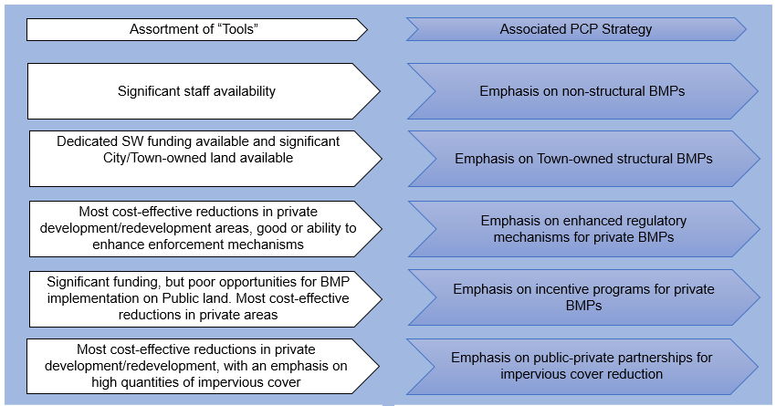
Figure 2. Example Tools and Associated Strategies
As you select strategies, you can then begin estimating approximate planning level phosphorus credits that can be realized from each strategy. These estimates can be calculated via multiple tools, which are detailed below. Continue adding strategies, moving down your ranked list from Table 13, until your planning level analysis illustrates your suite of strategies will achieve your overall PCP target. Be sure to work from the values reported in your PCP Template and the Calculation Support Worksheets in Appendix R.2, which account for actions taken since 2005.

Combine Tools and Select Strategies:
Start with the top four or five tools from Table 13 and develop strategies for each that seem most easily implemented in your municipality.

Table 14. Tool to Strategy Table
Tool | Strategy | Notes
Ex. Well trained staff and Town-owned maintenance equipment | Employ enhanced street sweeping program | Determine feasibility of implementing at various levels (twice a year, monthly, weekly)

Estimate Phosphorus Credits for Selected Strategies:
See Appendix R.4 for a full list of resources to estimate benefits. Workshops #2 and #3 also walk through the calculations for non-structural and structural control credits.

Begin estimating phosphorus credits based on the equations and guidance in Attachments 2 and 3 to Appendix F. Report estimated benefits for each tool and strategy combination in Table 2, and maintain a running total credit to track until you’ve reached your PCP goal. Start with the easiest strategies to implement (e.g. top ranked tools, like non-structural BMPs and structural BMPs on publicly owned land) and iteratively add strategies. These will likely change over the life of the PCP, but this provides a guide at the outset and will inform the written Phase I PCP.

Re-Report Item 2.7 (See Appendix R.2) : Remaining Phosphorus Reduction Requirement: ________ lb/yr
Note: The exercises undertaken in the Calculation Support Worksheet 2 in Appendix R.2 indicate how development and any changes in land use and impervious area added phosphorus loads. This updating of annual loads to current conditions (i.e. calculating Item 2.2) is not static – as development continues to happen, your loads will change. This will move the dial on how much is required to achieve your goal since the static target is your Allowable Phosphorus Load (Item 1.3). So, while this exercise in Table 3 below is meant to chart your entire path, know that significant development and increases in load over the Permit term could create a larger reduction requirement needed to achieve your Allowable Phosphorus Load. (See Workshop #2)
Table 15. Strategy Accounting Table
Tool | Strategy | Estimated P Credit (lb/yr) | Notes
Ex. Well trained staff and Town-owned maintenance equipment | Employ enhanced street sweeping program – Monthly | 3.7 | Assuming monthly was selected because it maximized credit while maintaining an implementable plan.
Local regulations | Strengthen stormwater regulations | 50 | Five developments/redevelopments each getting 10 lbs/yr of P-credit
Keep adding columns above as needed.
TOTAL P CREDIT |  | Sum of above columns

The strategies in Table 3 will directly feed your written Phosphorus Control Plan.

